**HW 11: Testing Progress**

**Objectives:**

Provide Testing Progression based on the data given.

**Assignment:**

You have 8 weeks total, and you're already at the end of week 6. You need to pull together a presentation for your boss on release status, and whether you think it will be ready to go at the end of 8 weeks based on the given information in excel and below release criteria:

Reliability:

<= 2 failures per day expected in operation

System Test Complete:

>= 99% tests executed

>=98% tests passed

<= 20 open defects

**Author:** Prateek Singh Chauhan

**Pledge:** “I pledge on my honor that I have not given or received any unauthorized assistance on this assignment/examination. I further pledge that I have not copied any material from a book, article, the Internet, or any other source except where I have expressly cited the source.”

**Solution:**

**Release Criteria: System Testing**

Chart of System testing with Trendline (Chart 1):

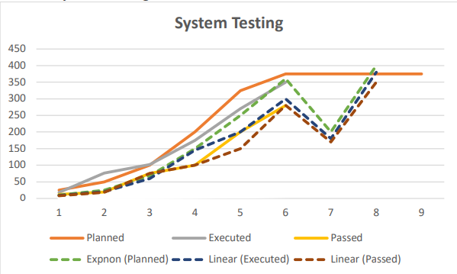

Chart of System test Percentage compared to Planned test (Chart 2):

Based on the data provided, data has some discrepancy on 2nd and 3rd week when calculated the percentage of Executed test w.r.t. Planned Test in Chart 2. From the percentage plot we can see a gradual decrease in Passed percentage in sprint 7 to 90% from 93% in the 6th week. But we can see that the Passed Percentage when compared to Planned test is increasing gradually over the sprints.

Also, from the above System testing chart with trend line (Chart 1), we can say that when testing planned and executed, the test is passed are increasing. This indicates that the platform is going up and quality of release is good and increasing and defects are getting reduced with time.

With assumption of +/- 15% of the plan limit control and increase in ratio of Passed Test wrt Planned test per sprint in Chart 1, we can assume that system test passed percentage will reach 98% by the 8th sprint.

**Release Criteria Satisfied:**

**>= 99% tests executed: PASSED**

**>=98% tests passed: PASSED**

**Release Criteria: Open Bugs/Defects**

Based on the graph, we can see that the number of closed defects is gradually increasing while the sum of backlog and new defects are decreasing. For Total open defects in a certain sprint the formula will be:

***Open Defects = Backlog defects + New defects – Closed Defects***

For this information, below graph is plotted:

From the above graph, we can interpret that in coming sprints the open defects will be approximately 15 using linear forecast from previous sprints which is <=20 open defects for release criteria.

**Release Criteria:**

**<=20 open defects: PASSED**

**Release Criteria: Failures per day (Operational Testing)**

From the graph, the Failures per execution day is decreasing exponentially with every sprint. Using linear forecast, the expected failures per execution day will be less than around <2 and >0.

**Release Criteria:**

**<=2 Failures per day: PASSED**

**Questions:**

* **Will the release be ready to ship in 2 weeks? Why or why not?**

Based on the release criteria mentioned, while assuming +/-15% and release data calculated on given information have passed, product will be ready to ship in 2 weeks.

* **Given the historical data about previous releases, how many defects do you expect to find one year after the code is released?**

***Ratio of defects found in ST vs Field – for one year***

With the above chart, it depicts that ratio of defects decreases with the system testing vs field within one year. It is expected to hold out to 1.05 after the Release R5.